**BIG DATA LAB REPORT**

YUTIKA KULWE

CED15I017

28TH MARCH 2019

Dataset: <https://www.kaggle.com/petersunga/google-amazon-facebook-employee-reviews>

1. Establish association between attributes and stars rating.
   1. How to run the program:
      1. python arm.py
   2. Input: All the attributes of the dataset.
   3. Implementation: Apyori library was used to implement Apriori, which helped in establishing associations between the attributes and stars rating.
   4. Code:

from sklearn import metrics

from collections import Counter

from scipy.spatial.distance import pdist,squareform

import numpy as np

import matplotlib.pyplot as plt

import pandas as pd

from apyori import apriori

from tqdm import tqdm

store_data = pd.read_csv('yutika.csv')

records = []

for i in range(98):

records.append([str(store_data.values[i,j]) for j in range(9)])

association_rules = apriori(records, min_support=0.0002, min_lift=3, min_length=2)

association_results = list(association_rules)

for item in association_results:

# first index of the inner list

# Contains base item and add item

pair = item[0]

items = [x for x in pair]

confidence = item[2][0][2]

lift = item[2][0][3]

print("Rule: " + items[0] + " -> " + items[1])

#second index of the inner list

support_AC = item[1]

support_A = support_AC / confidence

support_C = confidence / lift leverage = support_AC - support_A*support_C

print("=====================================")

* 1. Output:

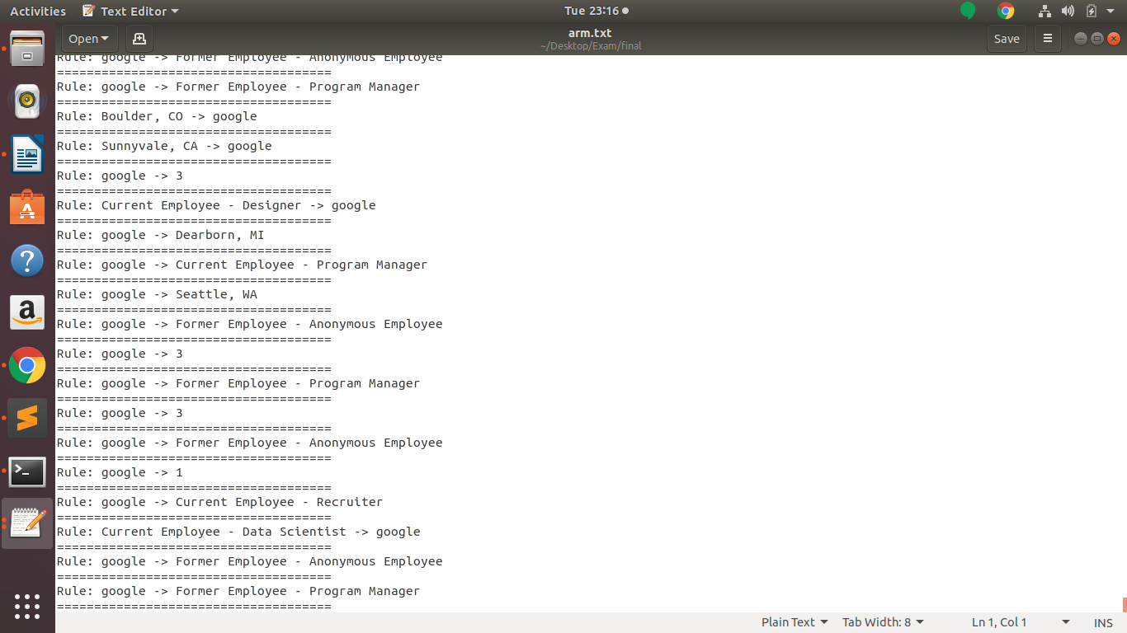

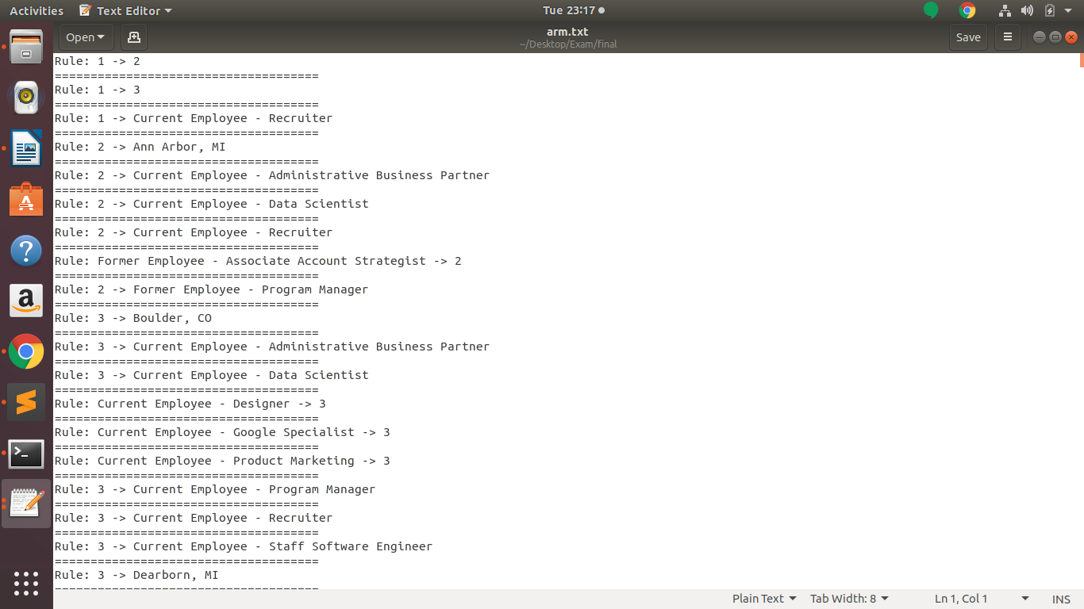

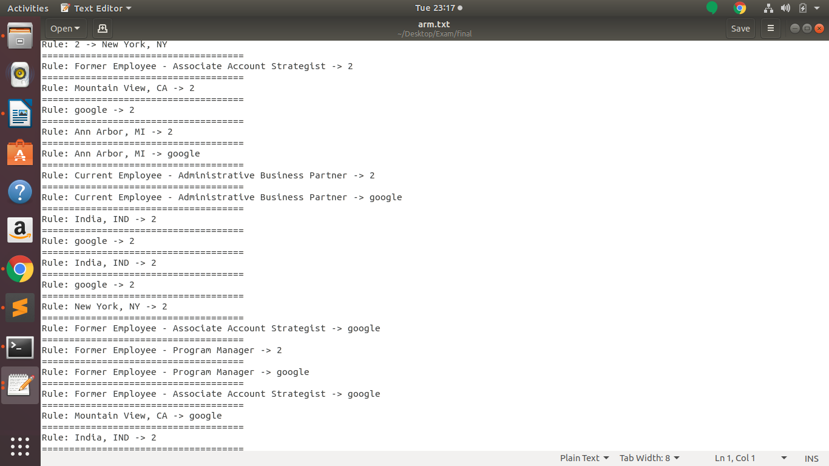

1. Fit any two classifiers for each stars rating.
   1. How to run the program:
      1. python 1RF.py
      2. python 1GB.py
   2. Input: Stars rating column
   3. Implementation: RandomForest classifier and GradientBoost classifier are used in this. You need to change to specific stars rating column in the code itself.
   4. Code:

*RANDOMFOREST CLASSIFIER:*

import matplotlib.pyplot as plt

import seaborn as sns

#import the data, specify data types

import pandas as pd

import numpy as np

import matplotlib.pyplot as plt

#%matplotlib inline

import seaborn as sns

import re

import pickle

#import mglearn

import time

from nltk.tokenize import TweetTokenizer

import nltk

from nltk import Text

from nltk.tokenize import regexp_tokenize

from nltk.tokenize import word_tokenize

from nltk.tokenize import sent_tokenize

from nltk.corpus import stopwords

from nltk.stem import WordNetLemmatizer

from nltk.stem import PorterStemmer

from sklearn.feature_extraction.text import CountVectorizer

from sklearn.feature_extraction.text import TfidfVectorizer

from sklearn.linear_model import LogisticRegression

from sklearn.naive_bayes import MultinomialNB

from sklearn.multiclass import OneVsRestClassifier

from sklearn.model_selection import cross_val_score

from sklearn.model_selection import train_test_split

from sklearn import metrics

from sklearn.metrics import classification_report

from sklearn.metrics import confusion_matrix

from sklearn.model_selection import GridSearchCV

from sklearn.pipeline import make_pipeline

df=pd.read_csv('employee_reviews.csv')

df.dropna(inplace=True)

#df.drop(df.columns[0],axis=1,inplace=True)

non_cat = [f for f in df.columns if df.dtypes[f] != 'object']

cat = [f for f in df.columns if df.dtypes[f] == 'object']

def treat_missing_numeric(df,columns,how = 'mean'):

if how == 'mean':

for i in columns:

print("Filling missing values with mean for columns - {0}".format(i))

df.ix[:,i] = df.ix[:,i].fillna(df.ix[:,i].mean())

elif how == 'mode':

for i in columns:

print("Filling missing values with mode for columns - {0}".format(i))

df.ix[:,i] = df.ix[:,i].fillna(df.ix[:,i].mode())

elif how == 'median':

for i in columns:

print("Filling missing values with median for columns - {0}".format(i))

df.ix[:,i] = df.ix[:,i].fillna(df.ix[:,i].median())

elif how == 'ffill':

for i in columns:

print("Filling missing values with forward fill for columns - {0}".format(i))

df.ix[:,i] = df.ix[:,i].fillna(method ='ffill')

elif type(how) == int or type(how) == float:

for i in columns:

print("Filling missing values with {0} for columns - {1}".format(how,i))

df.ix[:,i] = df.ix[:,i].fillna(how)

else:

print("Missing value fill cannot be completed")

return df

def treat_missing_categorical(df,columns,how = 'mode'):

if how == 'mode':

for i in columns:

print("Filling missing values with mode for columns - {0}".format(i))

df.ix[:,i] = df.ix[:,i].fillna(df.ix[:,i].mode()[0])

elif type(how) == str:

for i in columns:

print("Filling missing values with {0} for columns - {1}".format(how,i))

df.ix[:,i] = df.ix[:,i].fillna(how)

elif type(how) == int or type(how) == float:

for i in columns:

print("Filling missing values with {0} for columns - {1}".format(how,i))

df.ix[:,i] = df.ix[:,i].fillna(str(how))

else:

print("Missing value fill cannot be completed")

return df

treat_missing_numeric(df,non_cat,how = 'mean')

treat_missing_categorical(df,cat,how = 'mode')

#print(df)

from sklearn.model_selection import train_test_split

X = df.copy()

X = df['company']

y = df['senior-mangemnet-stars']

def holdout_cv(X,y,size = 0.3, seed = 1):

X_train, X_test, y_train, y_test = train_test_split(X, y, test_size = size, random_state = seed)

return X_train, X_test, y_train, y_test

X_train, X_test, y_train, y_test = holdout_cv(X, y, size = 0.3, seed = 1)

from sklearn.ensemble import RandomForestClassifier

from sklearn.datasets import make_classification

X, y = make_classification(n_samples=67528, n_features=4,

n_informative=2, n_redundant=0,

random_state=0, shuffle=False)

clf = RandomForestClassifier(n_estimators=100, max_depth=2,

random_state=0)

clf.fit(X, y)

print(clf.feature_importances_)

#print(clf.fit(X, y))

n=clf.predict(list(X))

#print(n)

for i in range(1,len(n)+1):

print("the",i,"went to class",n[i-1])

#print(clf.predict(list(X)))

*GRADIENTBOOST CLASSIFIER:*

import matplotlib.pyplot as plt

import seaborn as sns

#import the data, specify data types

import pandas as pd

import numpy as np

import matplotlib.pyplot as plt

#%matplotlib inline

import seaborn as sns

import re

import pickle

#import mglearn

import time

from nltk.tokenize import TweetTokenizer # doesn't split at apostrophes

import nltk

from nltk import Text

from nltk.tokenize import regexp_tokenize

from nltk.tokenize import word_tokenize

from nltk.tokenize import sent_tokenize

from nltk.corpus import stopwords

from nltk.stem import WordNetLemmatizer

from nltk.stem import PorterStemmer

from sklearn.feature_extraction.text import CountVectorizer

from sklearn.feature_extraction.text import TfidfVectorizer

from sklearn.linear_model import LogisticRegression

from sklearn.naive_bayes import MultinomialNB

from sklearn.multiclass import OneVsRestClassifier

from sklearn.model_selection import cross_val_score

from sklearn.model_selection import train_test_split

from sklearn import metrics

from sklearn.metrics import classification_report

from sklearn.metrics import confusion_matrix

from sklearn.model_selection import GridSearchCV

from sklearn.pipeline import make_pipeline

df=pd.read_csv('employee_reviews.csv')

df.dropna(inplace=True)

#df.drop(df.columns[0],axis=1,inplace=True)

non_cat = [f for f in df.columns if df.dtypes[f] != 'object']

cat = [f for f in df.columns if df.dtypes[f] == 'object']

def treat_missing_numeric(df,columns,how = 'mean'):

'''

Function to treat missing values in numeric columns

Required Input -

- df = Pandas DataFrame

- columns = List input of all the columns need to be imputed

- how = valid values are 'mean', 'mode', 'median','ffill', numeric value

Expected Output -

- Pandas dataframe with imputed missing value in mentioned columns

'''

if how == 'mean':

for i in columns:

print("Filling missing values with mean for columns - {0}".format(i))

df.ix[:,i] = df.ix[:,i].fillna(df.ix[:,i].mean())

elif how == 'mode':

for i in columns:

print("Filling missing values with mode for columns - {0}".format(i))

df.ix[:,i] = df.ix[:,i].fillna(df.ix[:,i].mode())

elif how == 'median':

for i in columns:

print("Filling missing values with median for columns - {0}".format(i))

df.ix[:,i] = df.ix[:,i].fillna(df.ix[:,i].median())

elif how == 'ffill':

for i in columns:

print("Filling missing values with forward fill for columns - {0}".format(i))

df.ix[:,i] = df.ix[:,i].fillna(method ='ffill')

elif type(how) == int or type(how) == float:

for i in columns:

print("Filling missing values with {0} for columns - {1}".format(how,i))

df.ix[:,i] = df.ix[:,i].fillna(how)

else:

print("Missing value fill cannot be completed")

return df

def treat_missing_categorical(df,columns,how = 'mode'):

'''

Function to treat missing values in numeric columns

Required Input -

- df = Pandas DataFrame

- columns = List input of all the columns need to be imputed

- how = valid values are 'mode', any string or numeric value

Expected Output -

- Pandas dataframe with imputed missing value in mentioned columns

'''

if how == 'mode':

for i in columns:

print("Filling missing values with mode for columns - {0}".format(i))

df.ix[:,i] = df.ix[:,i].fillna(df.ix[:,i].mode()[0])

elif type(how) == str:

for i in columns:

print("Filling missing values with {0} for columns - {1}".format(how,i))

df.ix[:,i] = df.ix[:,i].fillna(how)

elif type(how) == int or type(how) == float:

for i in columns:

print("Filling missing values with {0} for columns - {1}".format(how,i))

df.ix[:,i] = df.ix[:,i].fillna(str(how))

else:

print("Missing value fill cannot be completed")

return df

treat_missing_numeric(df,non_cat,how = 'mean')

treat_missing_categorical(df,cat,how = 'mode')

#print(df)

from sklearn.model_selection import train_test_split

X = df.copy()

X = df['company']

y = df['senior-mangemnet-stars']

def holdout_cv(X,y,size = 0.3, seed = 1):

X_train, X_test, y_train, y_test = train_test_split(X, y, test_size = size, random_state = seed)

return X_train, X_test, y_train, y_test

X_train, X_test, y_train, y_test = holdout_cv(X, y, size = 0.3, seed = 1)

from sklearn.ensemble import GradientBoostingClassifier

from sklearn.datasets import make_classification

import pandas as pd

X, y = make_classification(n_samples=67528, n_features=4,

n_informative=2, n_redundant=0,

random_state=0, shuffle=False)

clf = GradientBoostingClassifier(n_estimators=100, max_depth=2,

random_state=0)

clf.fit(X, y)

print(clf.feature_importances_)

#print(clf.fit(X, y))

n=clf.predict(list(X))

#print(n)

for i in range(1,len(n)+1):

print("the",i,"went to class",n[i-1])

#print(clf.predict(list(X)))

e. Output:

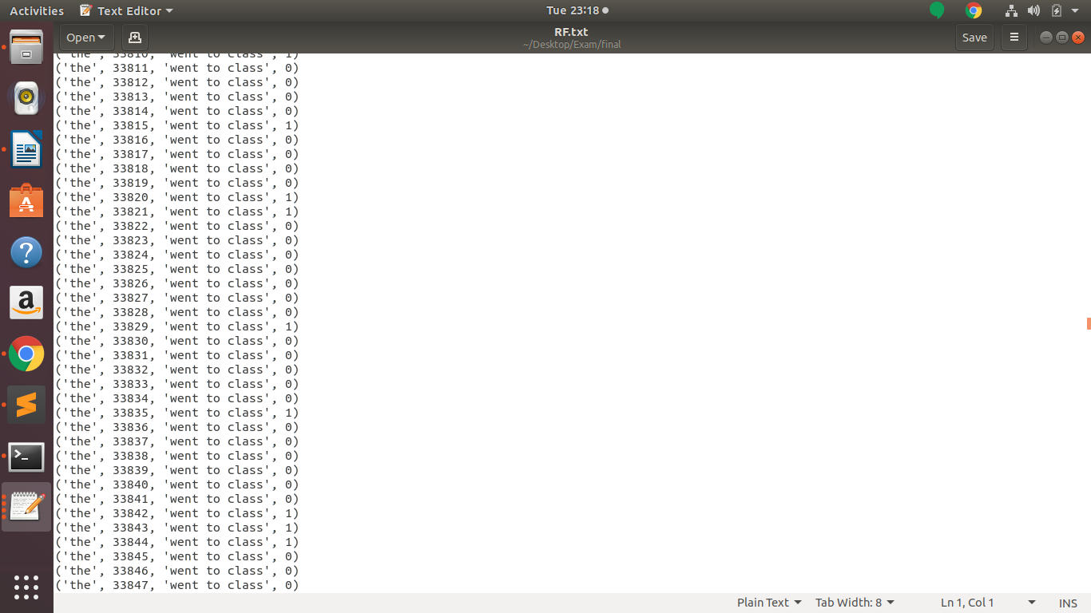

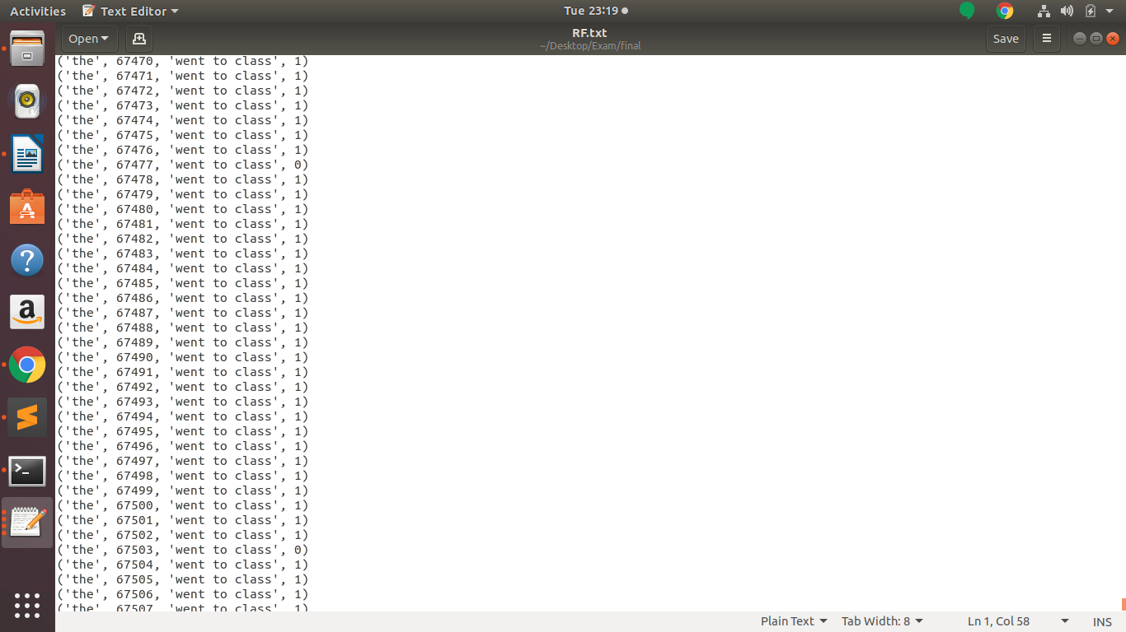

**RandomForest Classifier**

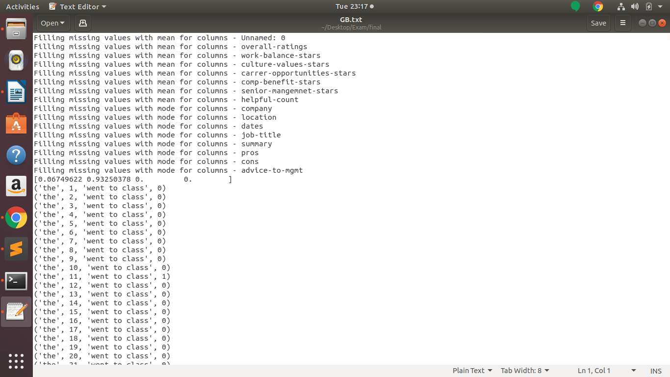

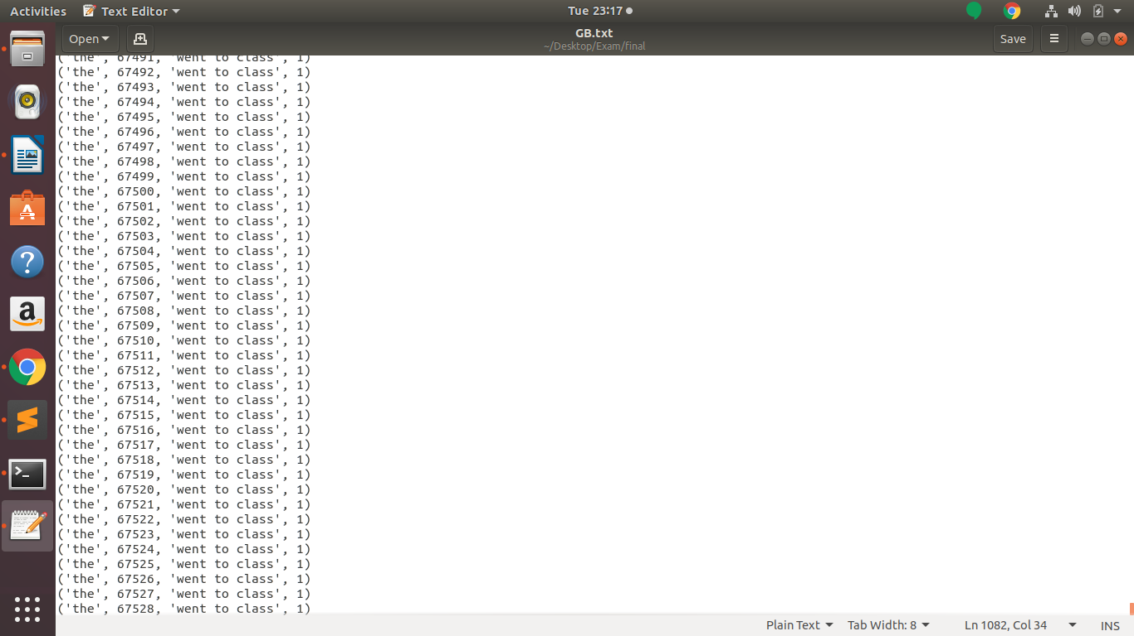

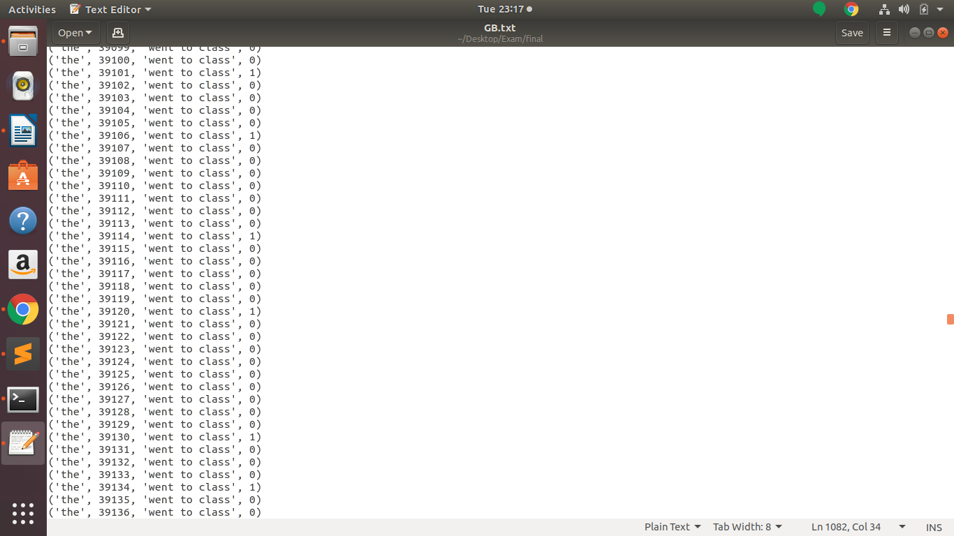

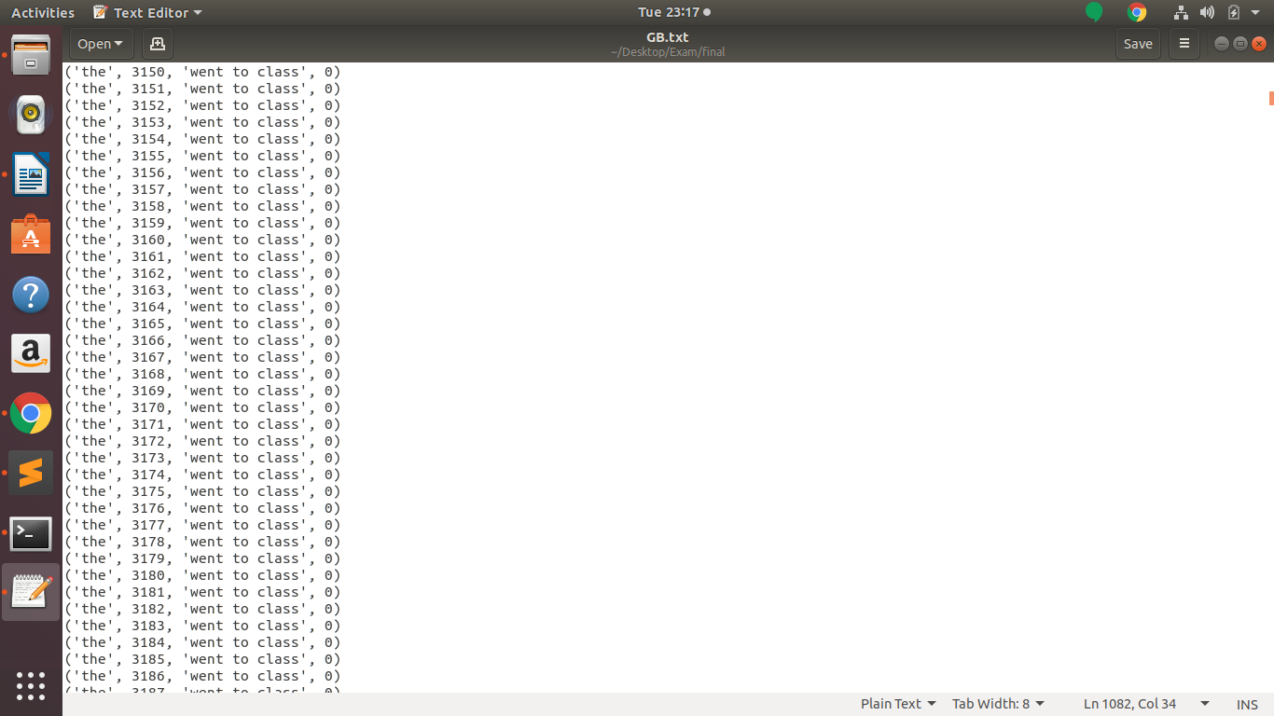

**Gradient Boost**

1. Cluster customer reviews using similarity metric.
   1. Kmeans clustering is used
   2. How to run the program:
      1. python kmeans.py
   3. Input: Customer reviews is factorized to group similar reviews together which is the summary column of the datatset. Here, “k” is 3. You can change the “k” value in the code.
   4. Implementation: It is implemented using sklearn,nltk library. Eucleadean distance is used to find the difference between two points and then cluster it. “pdist” is the inbuilt function in sklearn library that computes Euclidean distance.
   5. Code:

import matplotlib.pyplot as plt

import seaborn as sns

import pandas as pd

import numpy as np

import matplotlib.pyplot as plt

import seaborn as sns

import re

import pickle

import time

from nltk.tokenize import TweetTokenizer # doesn't split at apostrophes

import nltk

from nltk import Text

from nltk.tokenize import regexp_tokenize

from nltk.tokenize import word_tokenize

from nltk.tokenize import sent_tokenize

from nltk.corpus import stopwords

from nltk.stem import WordNetLemmatizer

from nltk.stem import PorterStemmer

from sklearn.feature_extraction.text import CountVectorizer

from sklearn.feature_extraction.text import TfidfVectorizer

from sklearn.linear_model import LogisticRegression

from sklearn.naive_bayes import MultinomialNB

from sklearn.multiclass import OneVsRestClassifier

from sklearn.model_selection import cross_val_score

from sklearn.model_selection import train_test_split

from sklearn import metrics

from sklearn.metrics import classification_report

from sklearn.metrics import confusion_matrix

from sklearn.model_selection import GridSearchCV

from sklearn.pipeline import make_pipeline

df=pd.read_csv('employee_reviews.csv')

df.dropna(inplace=True)

from pandas.api.types import CategoricalDtype

labels, uniques = pd.factorize(df['summary'])

print("Numeric Representation : \n", labels)

print("Unique Values : \n", uniques)

X = labels

print(X)

y, z = pd.factorize(df['company'])

X, y = X.tolist(), y.tolist()

print(X, y)

x = [[0 for i in range(2)] for j in range(len(X))]

for i in range(len(X)):

x[i][0] = X[i]

x[i][1] = y[i]

print(x)

from sklearn.cluster import KMeans

import numpy as np

#X = np.array([[1, 2], [1, 4], [1, 0],[10, 2], [10, 4], [10, 0]])

estimator=KMeans(n_clusters=3)

#kmeans = KMeans(n_clusters=2, random_state=0).fit(X)

#kmeans.labels_

y_kmeans=estimator.fit_predict(x)

for i in range(1,len(y_kmeans)+1):

print("the",i,"went to class",y_kmeans[i-1])

* 1. Output:

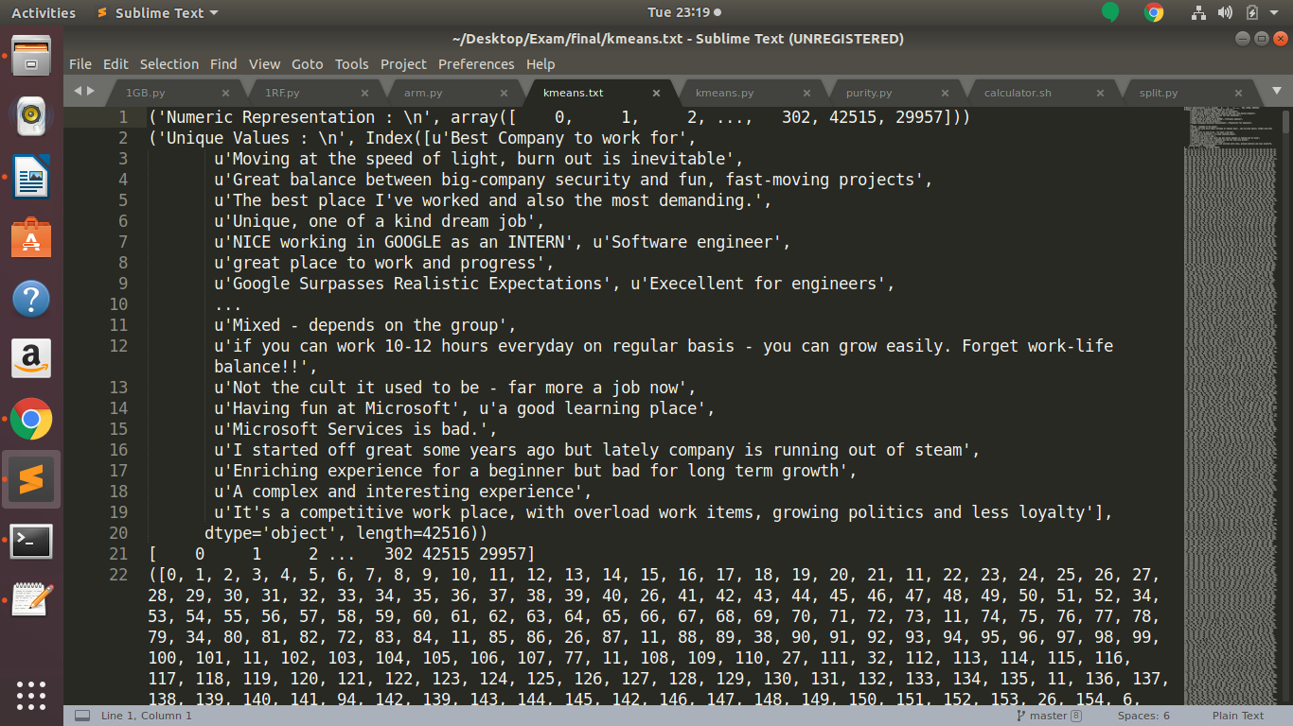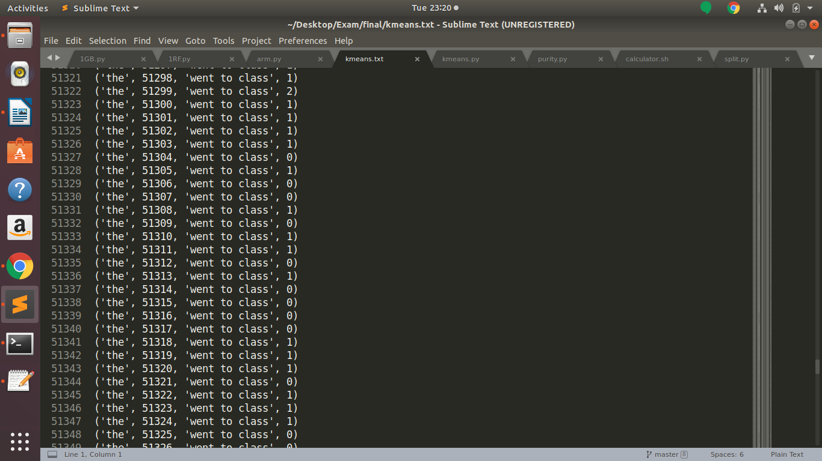

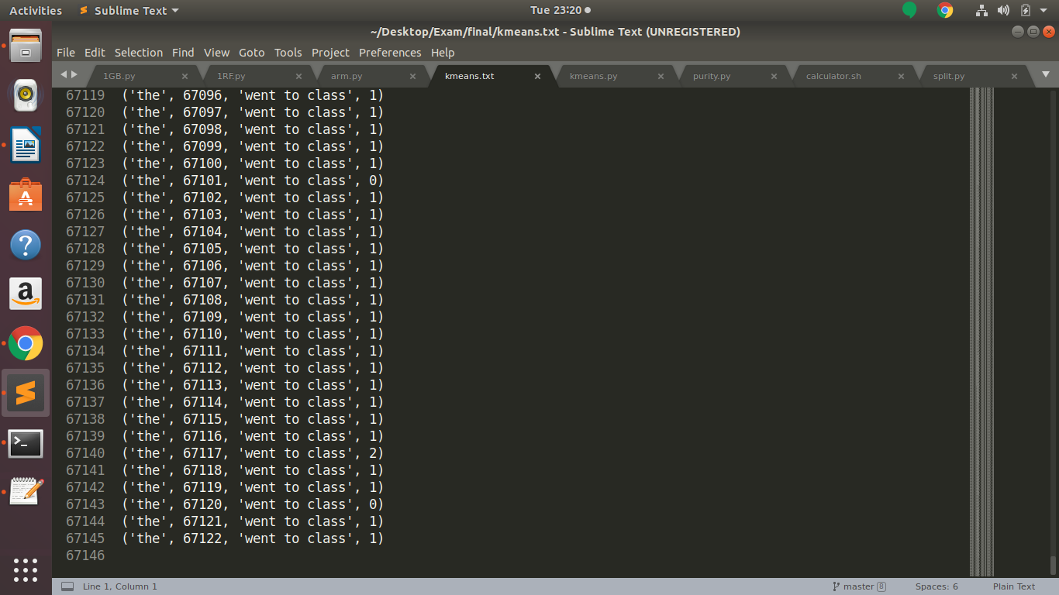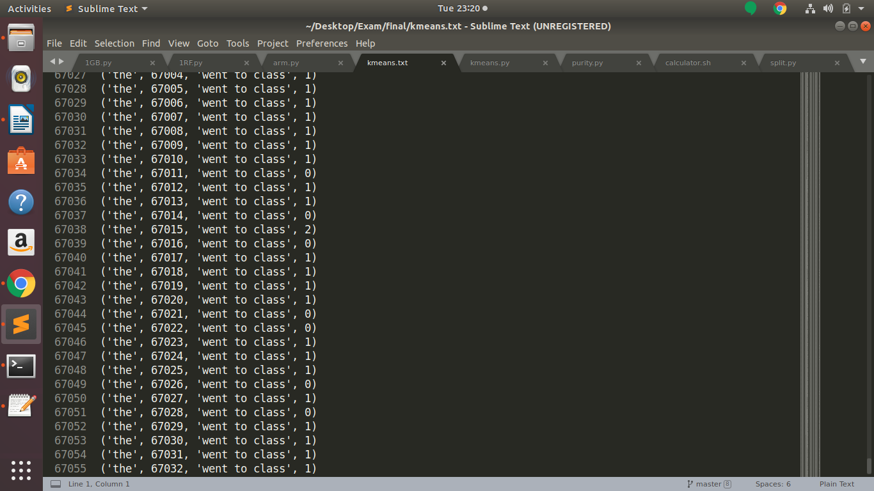

1. Evaluate the quality of clustering in Q3.
   1. Purity metric is used to evaluate the quality.
   2. How to run the program:
      1. Python purity.py
   3. Input: I’m randomly generating 10 datatpoints everytime and checking the purity of it.
   4. Implementation: We are computing Distances betweens two points, Cluster centres, Labels that tells which point is part of which cluster.
   5. Code:

import matplotlib.pyplot as plt

import numpy as np

from sklearn.cluster import KMeans

from sklearn import metrics

from collections import Counter

from scipy.spatial.distance import pdist,squareform

import random

X = np.array([[random.randint(0,67530),random.randint(0,67530)],

[random.randint(0,67530),random.randint(0,67530)],

[random.randint(0,67530),random.randint(0,67530)],

[random.randint(0,67530),random.randint(0,67530)],

[random.randint(0,67530),random.randint(0,67530)],

[random.randint(0,67530),random.randint(0,67530)],

[random.randint(0,67530),random.randint(0,67530)],

[random.randint(0,67530),random.randint(0,67530)],

[random.randint(0,67530),random.randint(0,67530)],

[random.randint(0,67530),random.randint(0,67530)],])

true_clusters_labels = [0,0,0,0,0,1,1,1,1,1]

plt.scatter(X[:,0],X[:,1], label='True Position')

kmeans = KMeans(n_clusters=3)

distances = kmeans.fit_transform(X)

print("=================Distances==================")

print(distances)

plt.scatter(X[:,0],X[:,1], c=kmeans.labels_, cmap='rainbow')

print("=================Cluster centres==================")

print(kmeans.cluster_centers_)

print("=================Labels==================")

print(kmeans.labels_)

predicted_labels = kmeans.labels_

num_of_members = Counter(predicted_labels)

cluster_radius = {x:0 for x in predicted_labels}

for distance,label in zip(distances,predicted_labels):

cluster_radius[label] += distance[label]

for label in num_of_members:

cluster_radius[label] /= num_of_members[label]

print('Cluster Radius : ',cluster_radius)

def purity_score(y_true, y_pred):

# compute contingency matrix (also called confusion matrix)

contingency_matrix = metrics.cluster.contingency_matrix(y_true, y_pred)

print("=================Contingency Matrix==================")

print(contingency_matrix)

# return purity

return np.sum(np.amax(contingency_matrix, axis=0)) / np.sum(contingency_matrix)

purity_score(true_clusters_labels,predicted_labels)

* 1. Output:

